**MIDDLETON CHENEY FOOTBALL CLUB**

**ANNUAL GENERAL MEETING**

**1993**

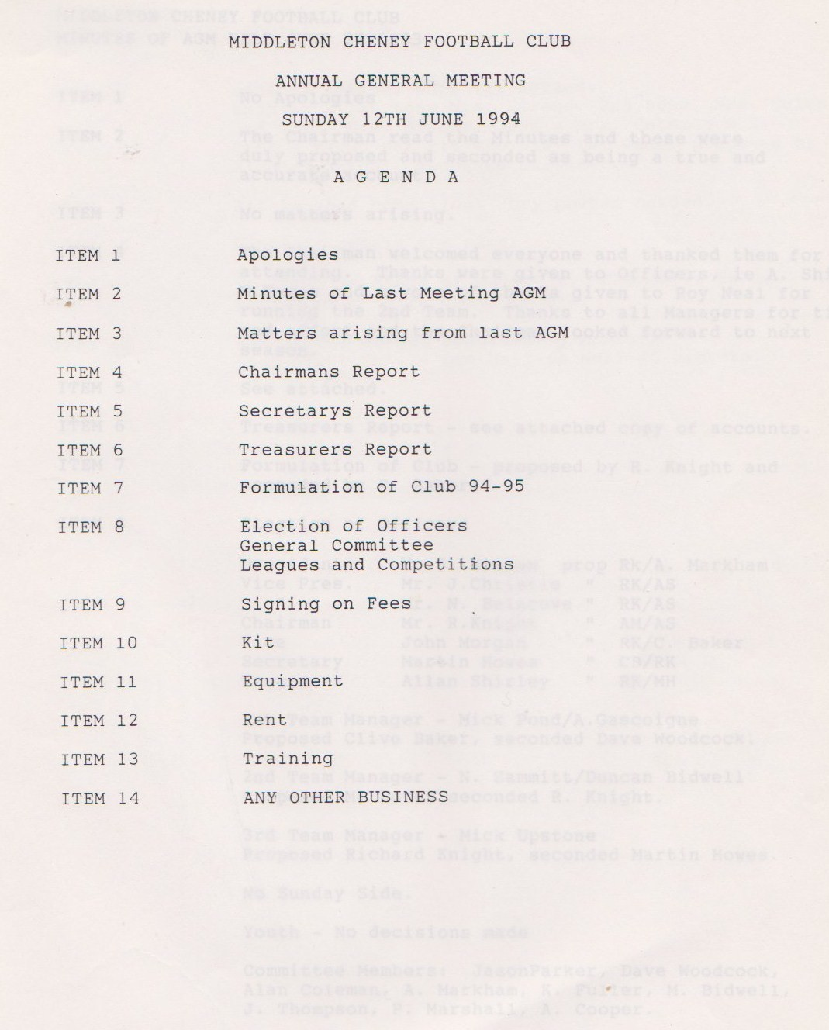

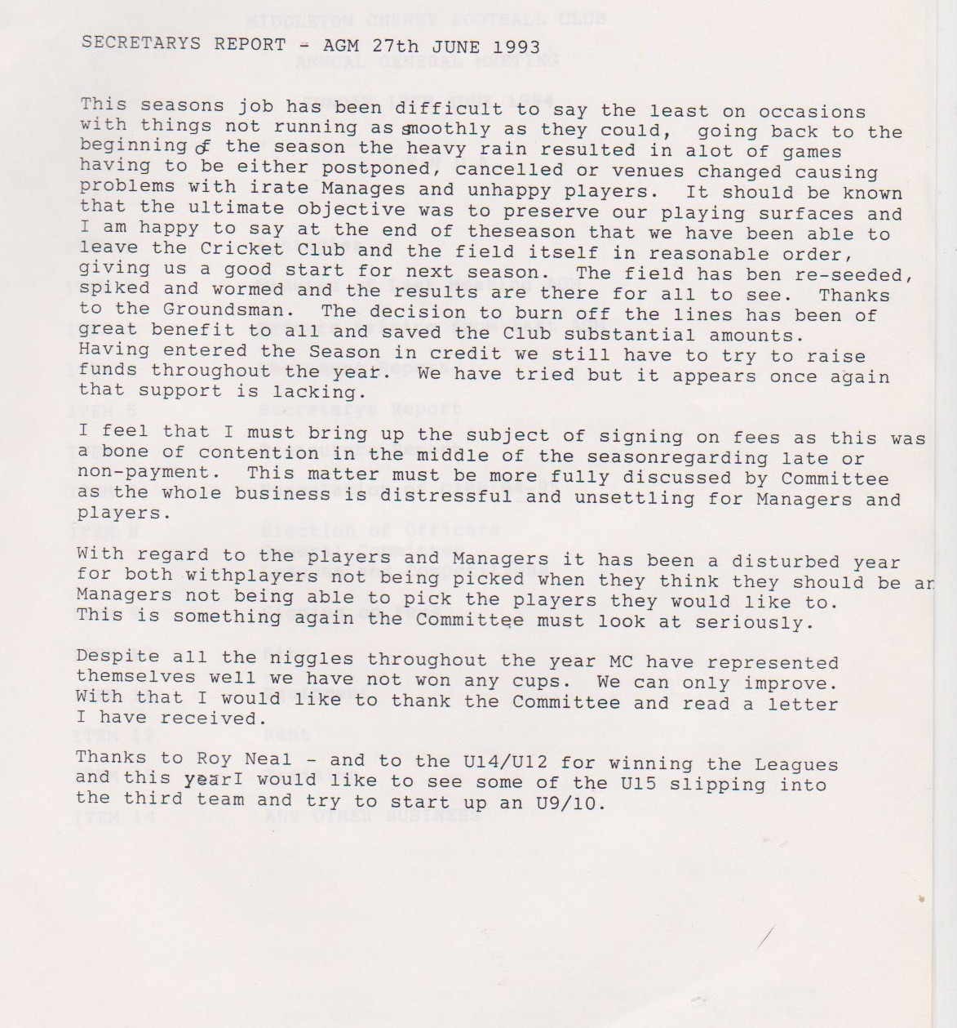

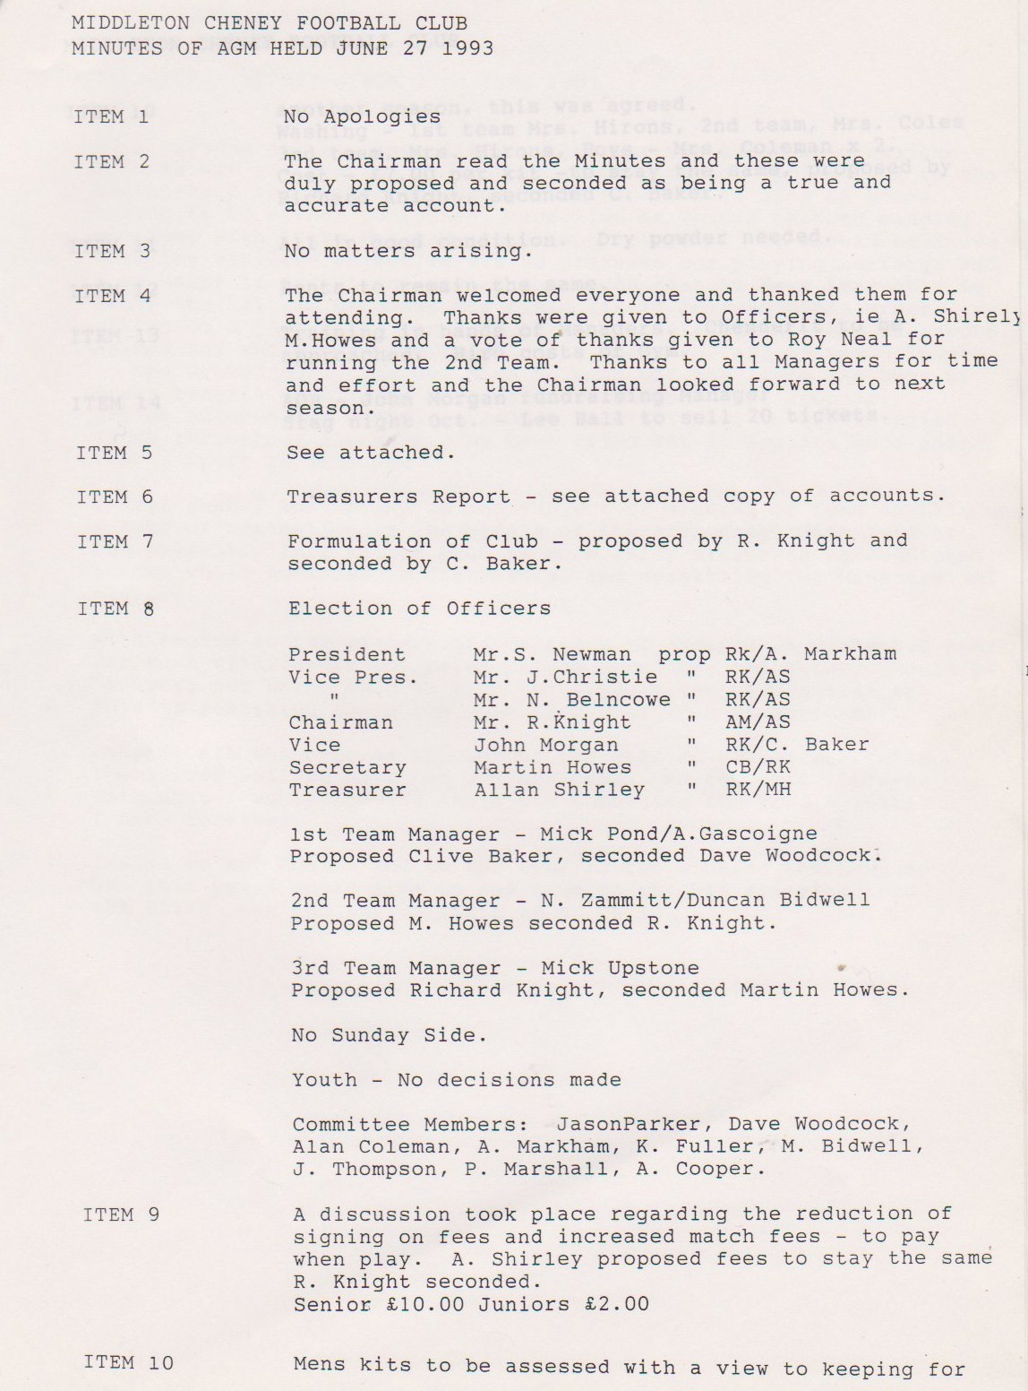

**Continued**

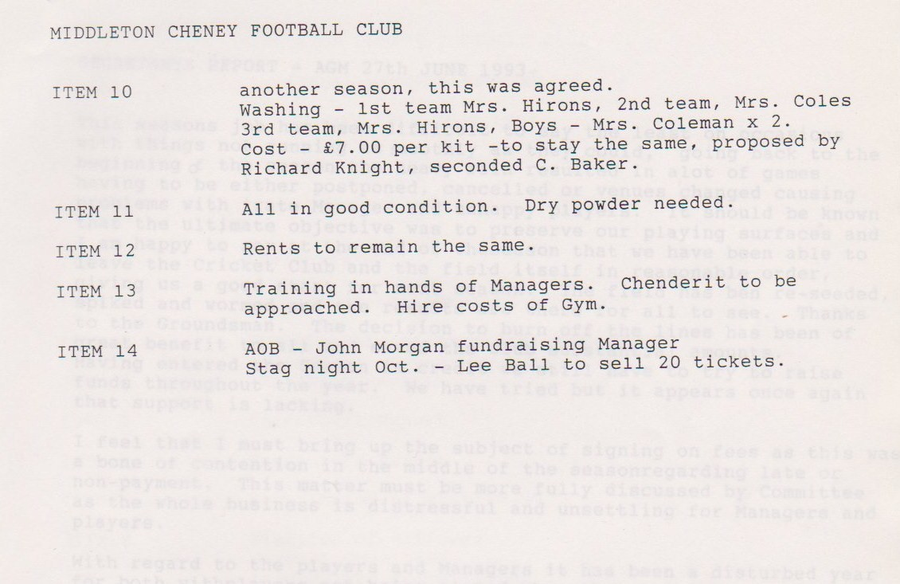

**General Committee Meeting**

**October 2nd 1993**

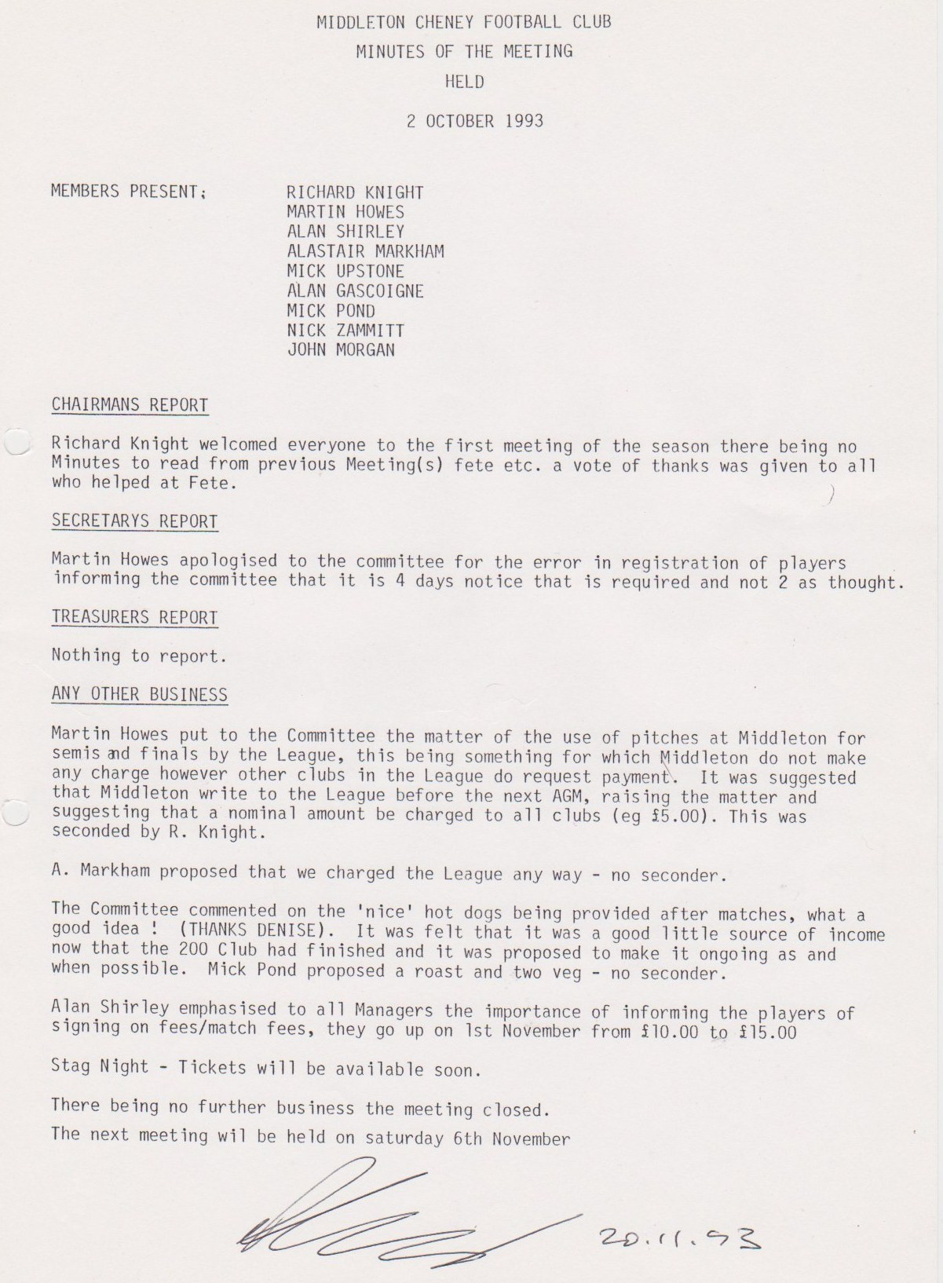

**General Committee Meeting**

**November 20th 1993**

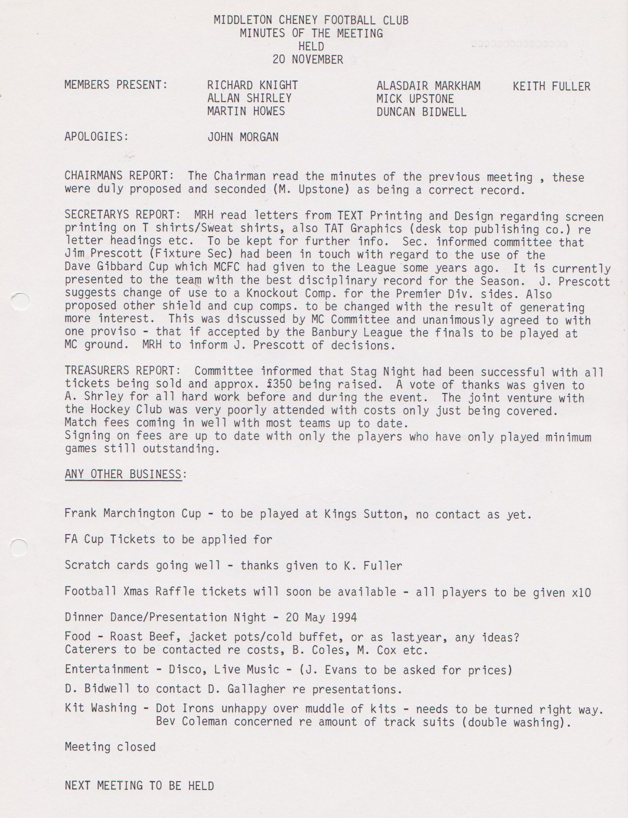

**General Committee Meeting**

**December 5th 1993**

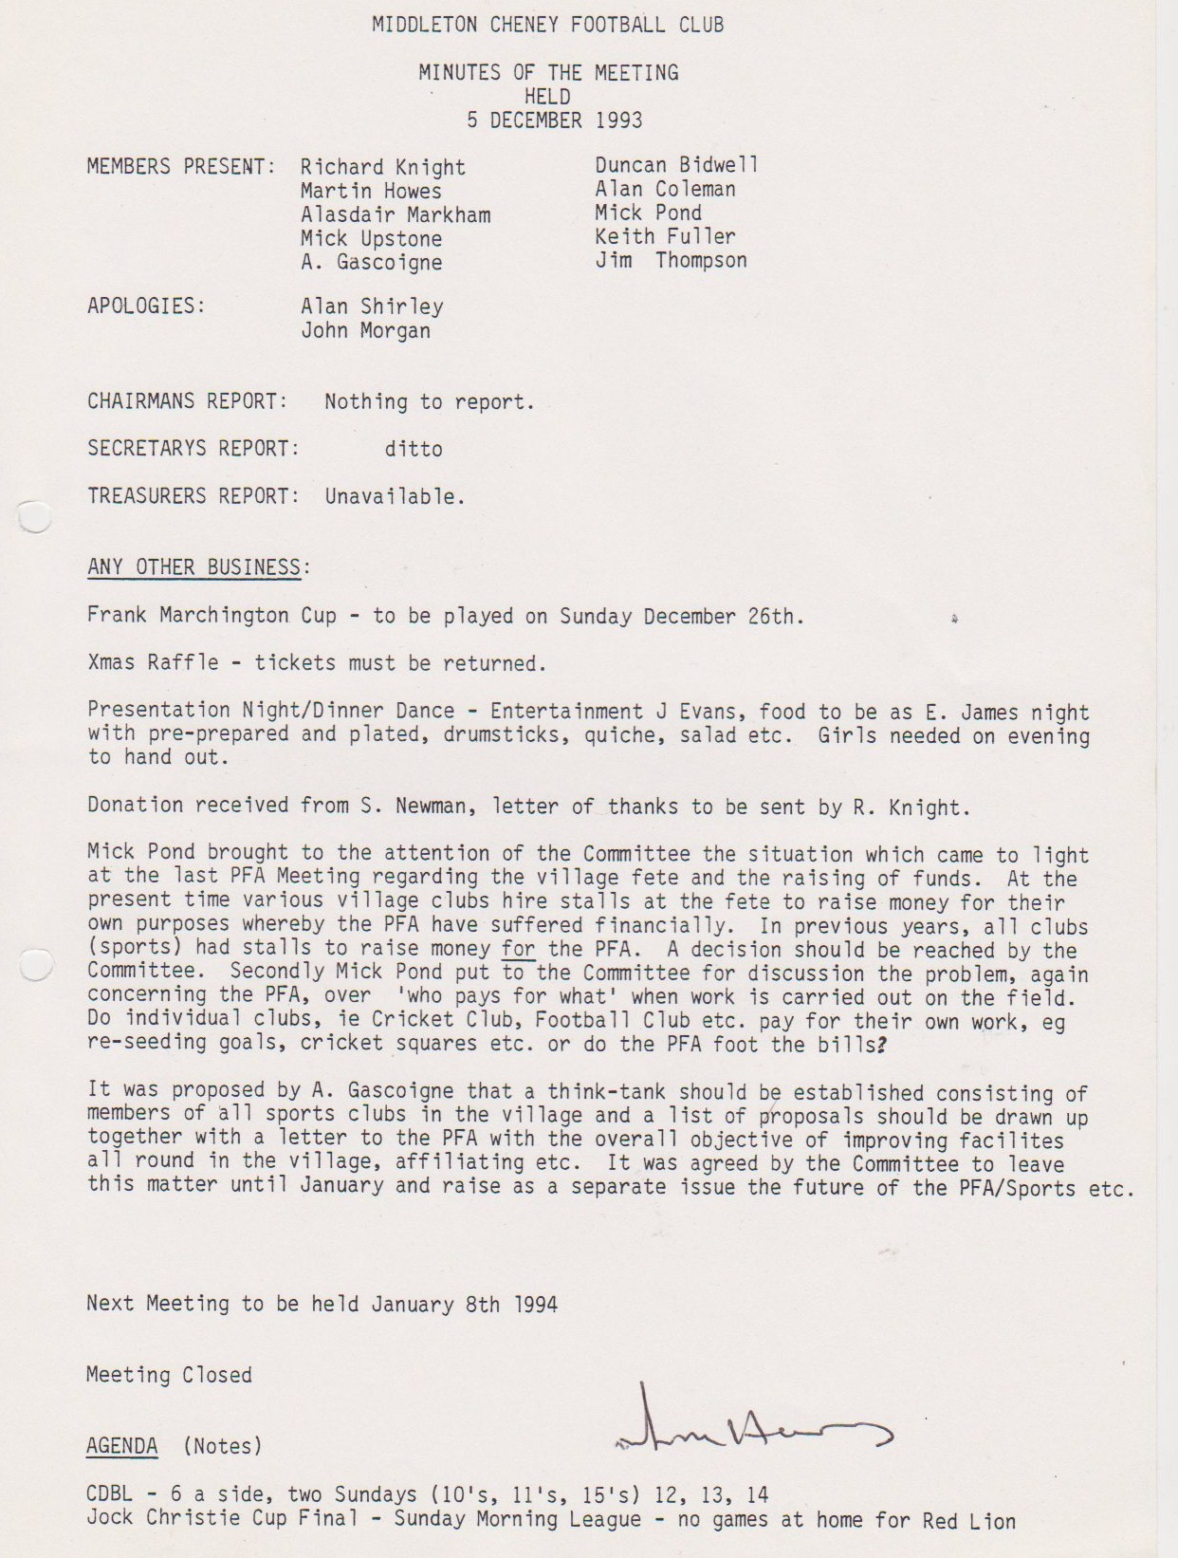

**General Committee Meeting**

**January 8th 1994**

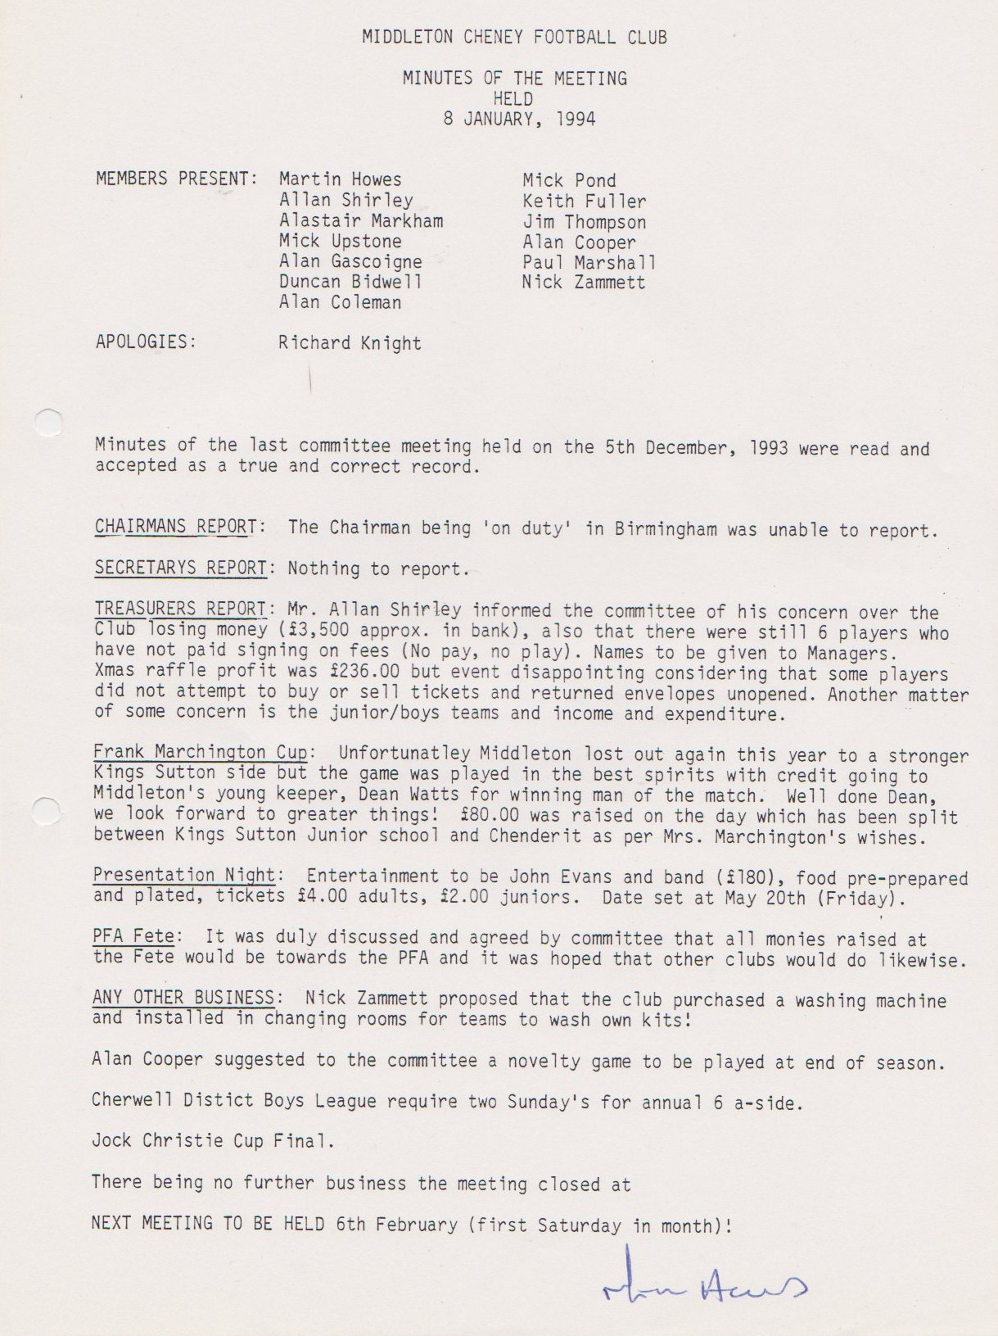

**General Committee Meeting**

**March 1994**

